Activity Report GS gain&sustain OG

Chance giving – Chance living

A project that connects young offenders with managers in order to build bridges between two different worlds. This project was done from 2009 – 2012 in Carinthia and Styria. For more information please visit our website: http://www.gainandsustain.eu/chancen-geben-chancen-leben/

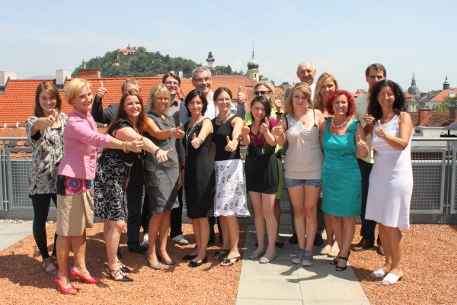

Coworking Alpe Adria

Getting the idea of coworking spread all over the region is the aim of that project. It connects coworking space opperators between each other and gives them the opportunity to work together. Furthermore the tourism between the countries Slovenia and Austria shall be stimulated. More information about this project you can find here: http://www.gainandsustain.eu/coworking-alpe-adria/.

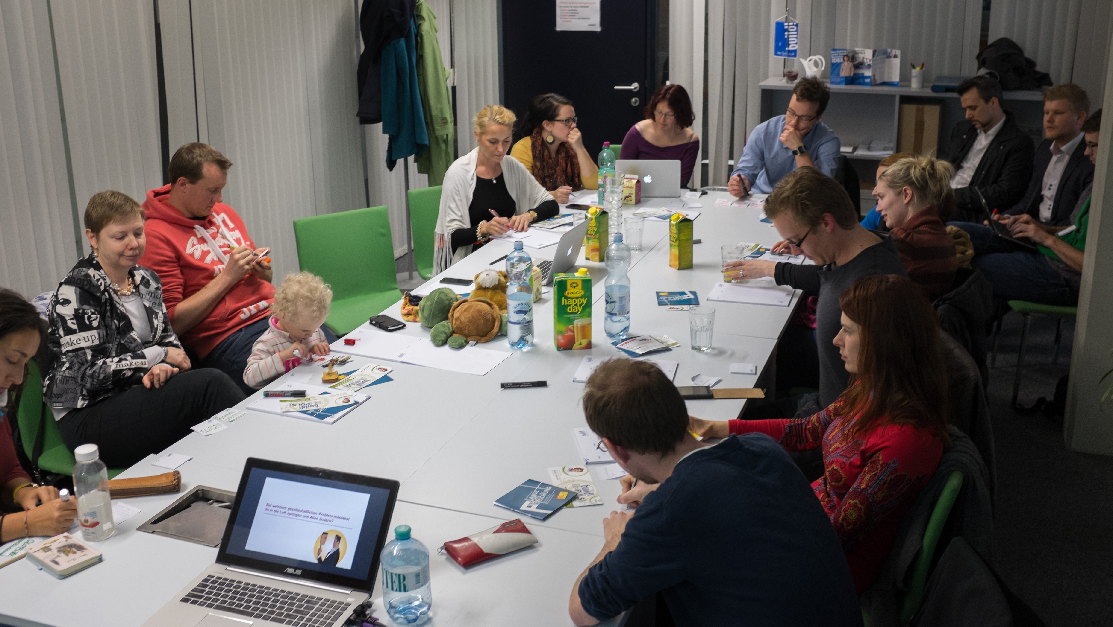

Battery Revolution

A national funded project that is awakening the interest of the technical field in kids. Schools and kindergarden kids were building energy storages in order to get more knowledge about the field. A big competition at the end of the project motivated the kids to give their passion to create new solutions.

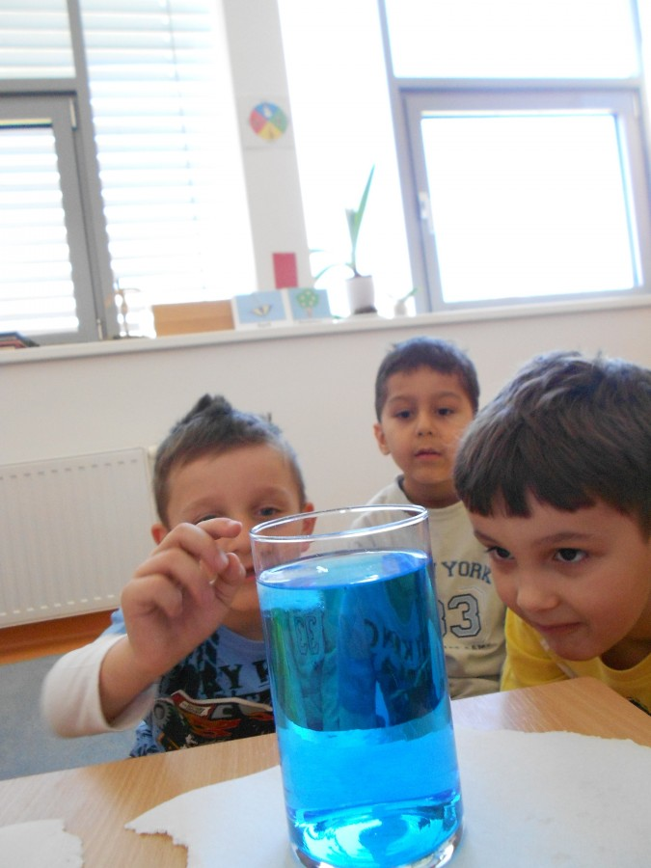

Bionik Kids

A project that is dedicated to spread the knowledge of Bionik between all categories of the societies. Starting at the professional level at the university of applied sciences – going to school children and then to kindergarden kids that were giving their knowledge to their parents.
This circle of knowledge was shared by people from different ages and backgrounds.
More information you find under: http://www.scienceclip.at/bionik_kids.html

